"When you chant this mantra with the breath of life, it's quick, it's purposeful, and it brings in what you need to bring in..."
Posture: Sit in Easy Pose with a straight spine, the chin is tucked in slightly and the chest is expanded out. Mentally straighten your spine so the channels can be clear. Bend the elbows by the sides and stretch the forearms across the diaphragm area, parallel to the floor. The right arm is on top and the left arm is underneath. The left hand grasps the right elbow and the right hand grasps the left elbow. The elbows should fit comfortably into the palms of each hand and the forearms should be tight across the diaphragm area.
Eyes: The eyes are closed.
Mental focus: The entire mantra is repeated on a single breath. The tone is a relaxed monotone that varies in emphasis automatically as you proceed through the stages of the mantra.
Chant:
11 minutes - chant aloud with the tape or in monotone
11 minutes - whisper powerfully. See what the pranic power does for you. From now until the end of the meditation, the body will go through changes. Keep the spine straight, elbows locked and contain the energy.
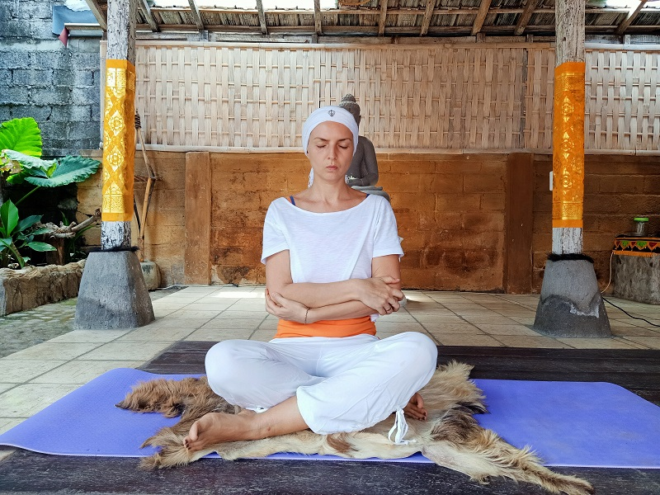
3 minutes - chant the mantra mentally, silently, moving your breath and the navel in rhythm with it for the remaining duration.
Mantra: download
HAR HAR HAR HAR GOBINDAY
HAR HAR HAR HAR MUKHANDAY
HAR HAR HAR HAR UDAARAY
HAR HAR HAR HAR APAARAY
HAR HAR HAR HAR HAREEANG
HAR HAR HAR HAR KAREEANG
HAR HAR HAR HAR NIRNAMAY
HAR HAR HAR HAR AKAAMAY
To end: Inhale deeply, stretch your spine as much as you can, squeeze the area where your elbows are locked, as well as every part of your body. Hold for 15-20 seconds. Cannon fire exhale through the mouth. Repeat 2 more times. Relax.

